Homework Microprocessor interfacing

ສຳລັບຫົວຂໍ້ທີ່ຈະເຮັດແມ່ນ Smoke Detection using Gas Sensor ເຊິ່ງເປັນການນຳເອົາເຊັນເຊີມາກວດຈັບຄວັນ ແລະ ຖ້າມີຄວັນຫຼາຍກວ່າທີ່ກຳນົດໄວ້ແມ່ນໃຫ້ມີການແຈ້ງເຕືອນ ເຊີ່ງມີຂັ້ນຕອນລາຍລະອຽດດັ່ງນີ້:

1. **ອຸປະກອນທີ່ໃຊ້:**

|  |  |  |  |
| --- | --- | --- | --- |
| ລ/ດ | ຮູບພາບອຸປະກອນ | ຊື່ອຸປະກອນ | ຈຳນວນ |
| 1 |  | Arduino UNO Board | 1 |
| 2 |  | Breadboard | 1 |
| 3 |  | MQ-2 Smoke detection sensor | 1 |
| 4 |  | Male/Female Jumper Wires |  |
| 5 |  | LED: Red | 1 |
| 6 |  | LED: Green | 1 |
| 7 |  | Buzzer | 1 |
| 8 |  | Resister 220 ohm | 3 |

1. 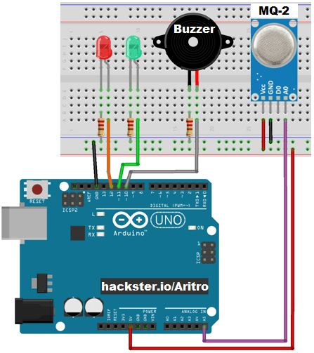**ວົງຈອນ:**

|  |  |
| --- | --- |
| Gas Sensor | |
| Vcc | 5V |
| GND | GND |
| D0 | Digital - |
| A0 | Analog A5 |

|  |  |
| --- | --- |
| Buzzer | Digital Pin10 |
| Red LED | Digital Pin12 |
| Green LED | Digital Pin11 |

1. Code:
2. /***********************************
3. Create By Mr. Khamphai KHOUNNAVONGSA
4. Date: 17/06/2016
5. ************************************
6. int redLed = 12;
7. int greenLed = 11;
8. int buzzer = 10;
9. int sensorGas = A5;
10. int smoke_level;
11. // end of Variable-------------------------------------------
12. void setup() {
13. Serial.begin(9600);
14. pinMode(redLed, UTPUT);
15. pinMode(greenLed, OUTPUT);
16. pinMode(buzzer, OUTPUT);
17. pinMode(sensorGas, INPUT);
18. } // end of setup---------------------------------------------
19. void loop() {
20. smoke_level = analogRead(sensorGas);
21. Serial.print("Pin A5: ");
22. Serial.println(smoke_level);
24. if (smoke_level > 300)
25. {
26. digitalWrite(redLed, HIGH);
27. digitalWrite(greenLed, LOW);
28. tone(buzzer, 1000, 200);
29. }
30. else
31. {
32. digitalWrite(redLed, LOW);
33. digitalWrite(greenLed, HIGH);
34. noTone(buzzer);
35. }
36. delay(100);
37. } // end of loop---------------------------------------------

